CP2406 ASSESSMENT 2

WORKING DOCUMENT

**Problem specification**

The problem is to create a traffic simulator according to traffic rules. The simulator needs to include vehicles, roads and traffic lights. You can change some settings of the simulator to simulate various situations.

**Problem decomposition using UML class diagram**

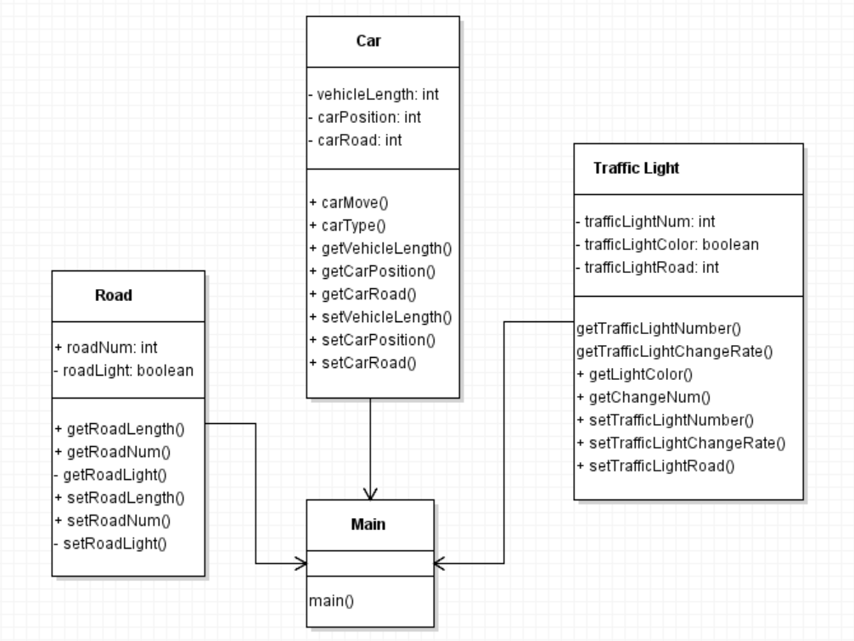

**Class Design**

- Main class

Main is a simulator, and other objects will be created under main. Mainly can control the car level, road level and traffic signal level. The main purpose is to collect all classes and let them interact directly to achieve the simulator effect.

- Car Class

Car objects move between one or two road objects. Use road segments to track their location. The class also adds a driving method that increases the position by one. It is public because the emulator calls it repeatedly.

-Road Class

Length is private so that other objects cannot change its value. A Road object is needed for each of the other classes to be simulated.

-Traffic Light Class

It will be public as Main class repeatedly calls this method. Traffic Light keeps track of its position which is taken by the last Road length segment. The Traffic Light class keeps track of the Road it is on, position and its signal to go.

**Method design:**

- Car Class

The Car class method can be used repeatedly in the simulator to make the Car object move. The method adds one to the position member field.

-Road Class

Length is private so that other objects cannot change its value.

-Traffic Light Class

The method in the Traffic Light class randomly changes the Boolean signal value based on a percentage. It can add to display a string output stating the colour of the traffic light based on Boolean values. In this scenario, true is green whereas false is red.

GITHUB: <https://github.com/Chenkeyi0911>